Model 1123 communications satellite
Specifications and assembly instructions
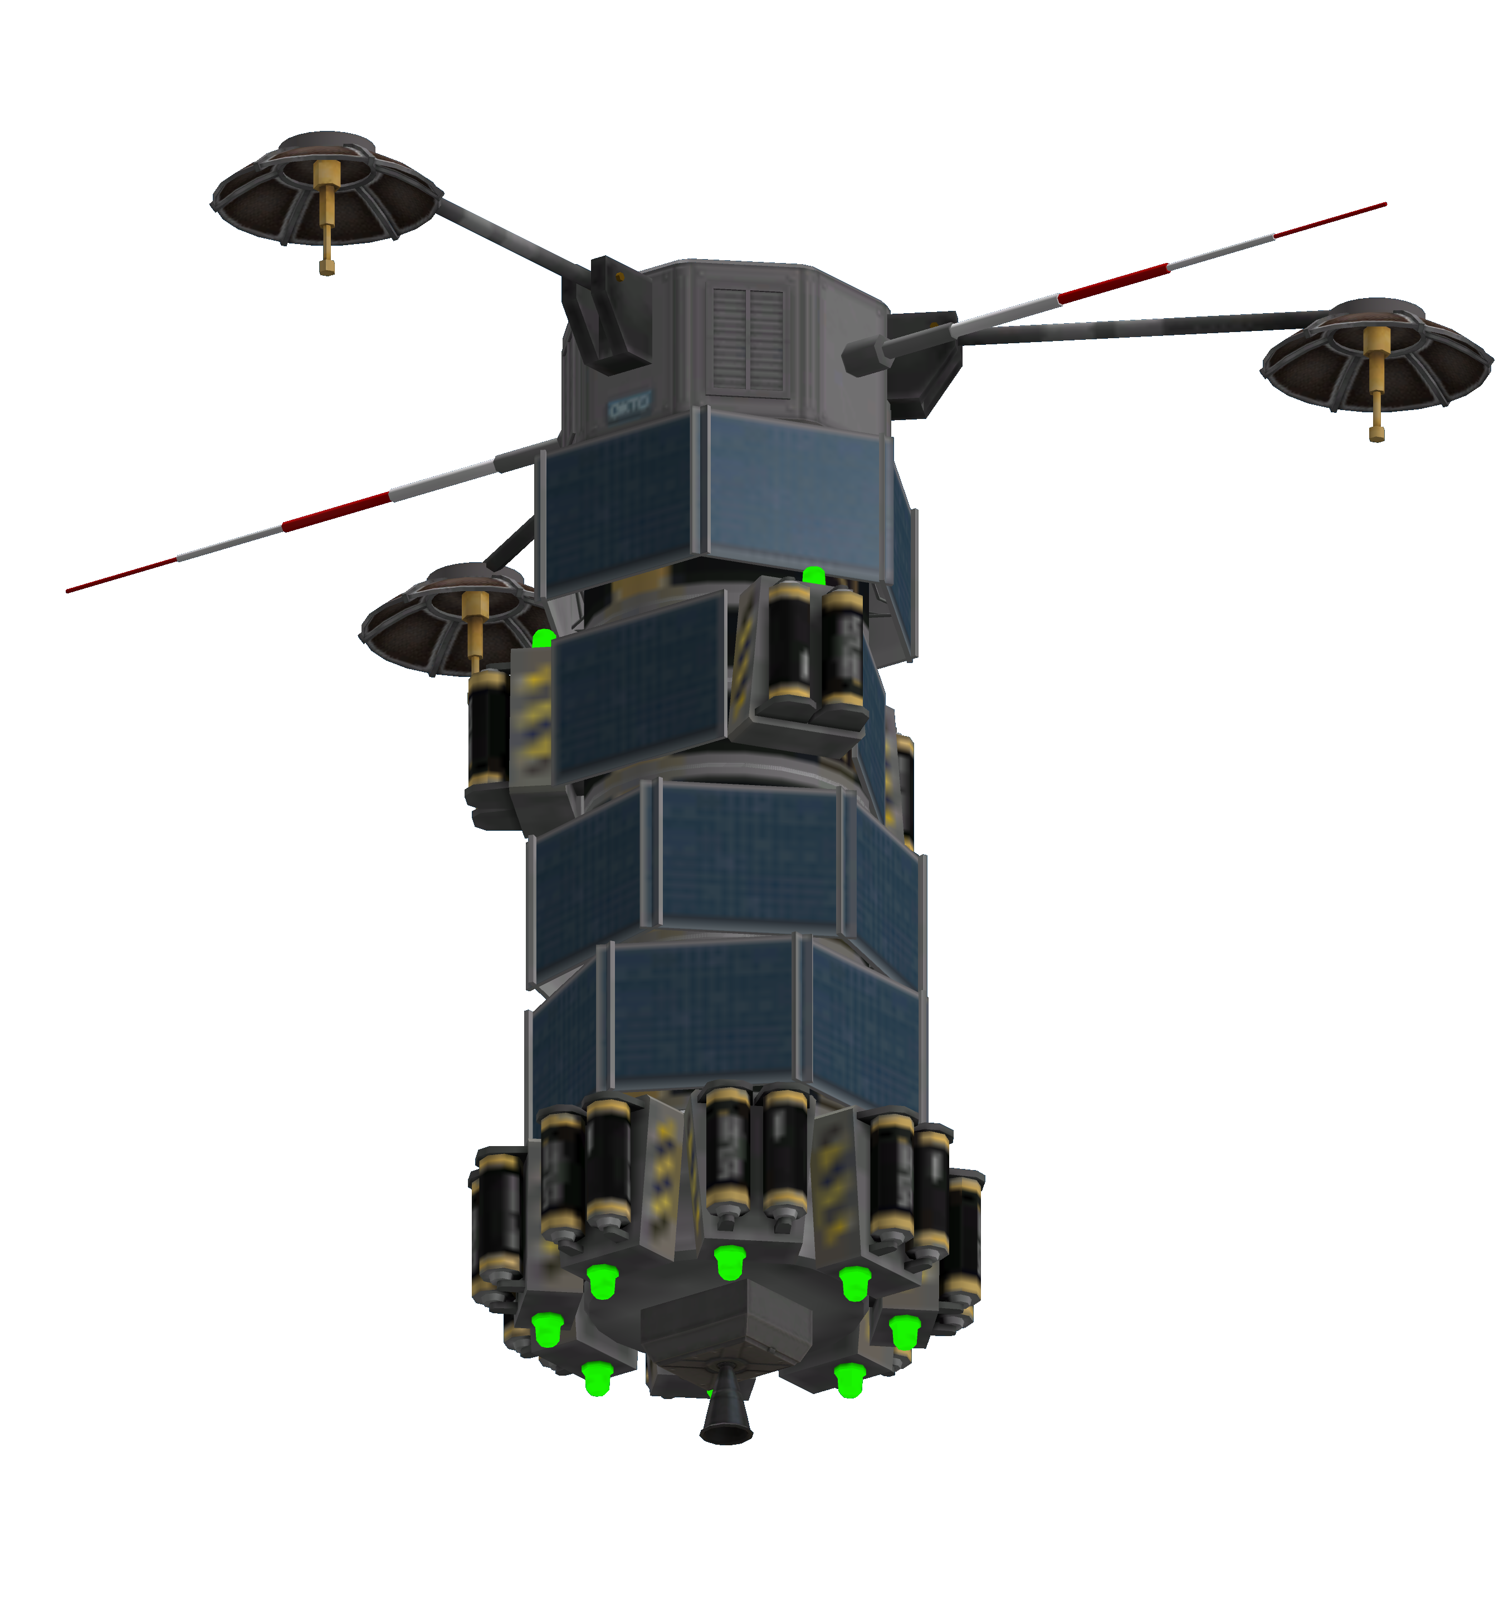

Description
The model 1123 satellite is an HG-5 based relay satellite that takes advantage of the wide angle of the HG-5 antenna to cover a large footprint on planetary surfaces. The presence of a second antenna allows the satellite to relay to off-world targets, to act as a close range (Mun to Kerbin) relay or as part of a larger communications network.

Variants
The satellite variants can be identified by the following suffixes
Model 1123[Y]
Where Y defines the attachment point and can be
Suffix | Type | Notes
(no suffix) | No attachment point
K | KAS JS-1 socket | KAS only
C | Clamp-o-Tron jr

Uses
TSC satellite
Mun-Kerbin relay
STC Satellite
General relay

Costs and tech

Costs
Base model | 8365 | Funds
Model K | 9115 | Funds
Model C | 9165 | Funds

Tech requirements
Technology | Use | Notes
Electrics | Probodobodyne OKTO  Z-200 Battery  OX-STAT Panel
Basic science | Z-100 Battery  HG-5 Antenna
Engineering 101 | Communotron 16
Propulsion systems | LV-1 Ant engine  OSCAR-B tank
Miniaturization | Clamp-O-Tron jr. | Model C only
Advanced construction | JS-1 socket | Model K only

Specifications

General specifications
Parameter | Value | Units | Notes
Electrical storage | 2710 | EC
Electrical storage margin | 15 | % | kerbostationary orbit
Electrical storage margin | 427 | EC | kerbostationary orbit
Max orbital alt (circular) | 4300 | Km | limited by battery storage
Min orbital alt (circular) | 640 | Km | limited by battery charger
Power consumption (absolute max) | 1.96 | EC/sec
Power consumption (deployment) | 0.28 | EC/sec | Omnis on, HG5 off, OKTO on, wheels idle
Power consumption (mission) | 1.91 | EC/sec | OKTO hibernating, wheels off, radios full on
Power generation (max) | 2.73 | EC/sec | Assumes 0.4 EC for 100% exposure
Power generation (max) | 6.83 | %Exposure
Power generation (min) | 2.61 | EC/sec | assumes panel ring oriented towards sun
Power generation (min) | 6.53 | %Exposure | assumes panel ring oriented towards sun
Power generation (avg) | 2.67 | EC/sec | assumes panel ring oriented towards sun
Power generation (avg) | 6.65 | %Exposure | assumes panel ring oriented towards sun
Thrust | 2 | kN
dV budget (vacuum) | 951 | m/s | 1122C
dV budget (vacuum) | 969 | m/s | 1122K
dV budget (vacuum) | 981 | m/s | 1122
Mass (wet) | 825 | Kg | 1122C
Mass (wet) | 813 | Kg | 1122K
Mass (wet) | 805 | Kg | 1122
Mass (dry) | 625 | Kg | 1122C
Mass (dry) | 613 | Kg | 1122K
Mass (dry) | 605 | Kg | 1122
Omni Antenna range | 1875 | Km | assumes root model, 0.5 range multiplier and 0.5 multiple antenna bonus

Power budget
All consumption in EC/second.
System | Unit consumption | Amount | Total consumption | Notes
Communotron 16 | 0.13 | 2 | 0.26
HG-5 | 0.55 | 3 | 1.65
Mission subtotal |  |  | 1.91
OKTO | 0.02 | 1 | 0.02
Systems subtotal |  |  | 1.93
Reaction wheel | 0.03 | 1 | 0.03
Abs. maximum |  |  | 1.96

Electrical generator performance
All figures assume side of power rings pointing towards the sun. Derate by cosine of angle to perpendicular of panels in other cases. Mission attitude is satellite perpendicular to ecliptic (direction measured as a line intersecting centre of computer section and centre of propulsion section).
Zero angle is at hardpoint 1 (where the computer label is).
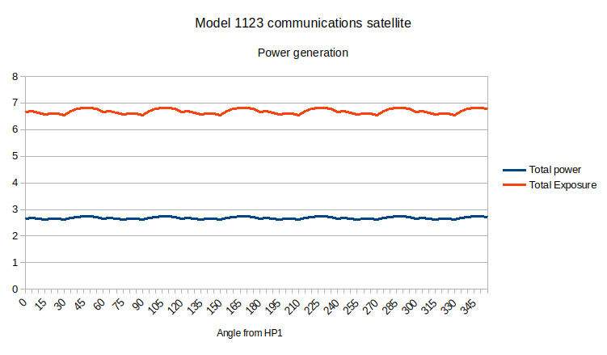
Angle | Total power | Total Exposure | UPSR | MPSR | LPSR | T3R
0 | 2.66 | 6.66 | 2 | 1.93 | 1.73 | 1
5 | 2.67 | 6.68 | 1.99 | 1.88 | 1.81 | 1
10 | 2.66 | 6.64 | 1.97 | 1.81 | 1.88 | 0.98
15 | 2.62 | 6.56 | 1.93 | 1.73 | 1.93 | 0.97
20 | 2.64 | 6.6 | 1.88 | 1.81 | 1.97 | 0.94
25 | 2.64 | 6.59 | 1.81 | 1.88 | 1.99 | 0.91
30 | 2.61 | 6.53 | 1.73 | 1.93 | 2 | 0.87
35 | 2.67 | 6.68 | 1.81 | 1.97 | 1.99 | 0.91
40 | 2.71 | 6.78 | 1.88 | 1.99 | 1.97 | 0.94
45 | 2.73 | 6.83 | 1.93 | 2 | 1.93 | 0.97
50 | 2.73 | 6.82 | 1.97 | 1.99 | 1.88 | 0.98
55 | 2.71 | 6.77 | 1.99 | 1.97 | 1.81 | 1
60 | 2.66 | 6.66 | 2 | 1.93 | 1.73 | 1
65 | 2.67 | 6.68 | 1.99 | 1.88 | 1.81 | 1
70 | 2.66 | 6.64 | 1.97 | 1.81 | 1.88 | 0.98
75 | 2.62 | 6.56 | 1.93 | 1.73 | 1.93 | 0.97
80 | 2.64 | 6.6 | 1.88 | 1.81 | 1.97 | 0.94
85 | 2.64 | 6.59 | 1.81 | 1.88 | 1.99 | 0.91
90 | 2.61 | 6.53 | 1.73 | 1.93 | 2 | 0.87
95 | 2.67 | 6.68 | 1.81 | 1.97 | 1.99 | 0.91
100 | 2.71 | 6.78 | 1.88 | 1.99 | 1.97 | 0.94
105 | 2.73 | 6.83 | 1.93 | 2 | 1.93 | 0.97
110 | 2.73 | 6.82 | 1.97 | 1.99 | 1.88 | 0.98
115 | 2.71 | 6.77 | 1.99 | 1.97 | 1.81 | 1
120 | 2.66 | 6.66 | 2 | 1.93 | 1.73 | 1
125 | 2.67 | 6.68 | 1.99 | 1.88 | 1.81 | 1
130 | 2.66 | 6.64 | 1.97 | 1.81 | 1.88 | 0.98
135 | 2.62 | 6.56 | 1.93 | 1.73 | 1.93 | 0.97
140 | 2.64 | 6.6 | 1.88 | 1.81 | 1.97 | 0.94
145 | 2.64 | 6.59 | 1.81 | 1.88 | 1.99 | 0.91
150 | 2.61 | 6.53 | 1.73 | 1.93 | 2 | 0.87
155 | 2.67 | 6.68 | 1.81 | 1.97 | 1.99 | 0.91
160 | 2.71 | 6.78 | 1.88 | 1.99 | 1.97 | 0.94
165 | 2.73 | 6.83 | 1.93 | 2 | 1.93 | 0.97
170 | 2.73 | 6.82 | 1.97 | 1.99 | 1.88 | 0.98
175 | 2.71 | 6.77 | 1.99 | 1.97 | 1.81 | 1
180 | 2.66 | 6.66 | 2 | 1.93 | 1.73 | 1
185 | 2.67 | 6.68 | 1.99 | 1.88 | 1.81 | 1
190 | 2.66 | 6.64 | 1.97 | 1.81 | 1.88 | 0.98
195 | 2.62 | 6.56 | 1.93 | 1.73 | 1.93 | 0.97
200 | 2.64 | 6.6 | 1.88 | 1.81 | 1.97 | 0.94
205 | 2.64 | 6.59 | 1.81 | 1.88 | 1.99 | 0.91
210 | 2.61 | 6.53 | 1.73 | 1.93 | 2 | 0.87
215 | 2.67 | 6.68 | 1.81 | 1.97 | 1.99 | 0.91
220 | 2.71 | 6.78 | 1.88 | 1.99 | 1.97 | 0.94
225 | 2.73 | 6.83 | 1.93 | 2 | 1.93 | 0.97
230 | 2.73 | 6.82 | 1.97 | 1.99 | 1.88 | 0.98
235 | 2.71 | 6.77 | 1.99 | 1.97 | 1.81 | 1
240 | 2.66 | 6.66 | 2 | 1.93 | 1.73 | 1
245 | 2.67 | 6.68 | 1.99 | 1.88 | 1.81 | 1
250 | 2.66 | 6.64 | 1.97 | 1.81 | 1.88 | 0.98
255 | 2.62 | 6.56 | 1.93 | 1.73 | 1.93 | 0.97
260 | 2.64 | 6.6 | 1.88 | 1.81 | 1.97 | 0.94
265 | 2.64 | 6.59 | 1.81 | 1.88 | 1.99 | 0.91
270 | 2.61 | 6.53 | 1.73 | 1.93 | 2 | 0.87
275 | 2.67 | 6.68 | 1.81 | 1.97 | 1.99 | 0.91
280 | 2.71 | 6.78 | 1.88 | 1.99 | 1.97 | 0.94
285 | 2.73 | 6.83 | 1.93 | 2 | 1.93 | 0.97
290 | 2.73 | 6.82 | 1.97 | 1.99 | 1.88 | 0.98
295 | 2.71 | 6.77 | 1.99 | 1.97 | 1.81 | 1
300 | 2.66 | 6.66 | 2 | 1.93 | 1.73 | 1
305 | 2.67 | 6.68 | 1.99 | 1.88 | 1.81 | 1
310 | 2.66 | 6.64 | 1.97 | 1.81 | 1.88 | 0.98
315 | 2.62 | 6.56 | 1.93 | 1.73 | 1.93 | 0.97
320 | 2.64 | 6.6 | 1.88 | 1.81 | 1.97 | 0.94
325 | 2.64 | 6.59 | 1.81 | 1.88 | 1.99 | 0.91
330 | 2.61 | 6.53 | 1.73 | 1.93 | 2 | 0.87
335 | 2.67 | 6.68 | 1.81 | 1.97 | 1.99 | 0.91
340 | 2.71 | 6.78 | 1.88 | 1.99 | 1.97 | 0.94
345 | 2.73 | 6.83 | 1.93 | 2 | 1.93 | 0.97
350 | 2.73 | 6.82 | 1.97 | 1.99 | 1.88 | 0.98
355 | 2.71 | 6.77 | 1.99 | 1.97 | 1.81 | 1

Assembly instructions
The satellite is based on the SpaceBus 1 satellite design and can be built using the standard parts. The following table presents the modules stacked in order, with angle of rotation relative to the computer module.
Module | Type | Angle | Notes
Computer | Computer | 0 | Module defines zero angle
UPS | Type 1 PSU | 0
T3 | Type 3 PSU | 0 | HG-5 rest on top of OX-STAT
MPS | Type 1 PSU | 15
LPS | Type 1 PSU | 30
Propulsion | Type 1 propulsion | 0

Hardpoint | Device | Notes
1 | HG-5 antenna | Use 3x symmetry. Apply on HP 1.
2 | Empty
3 | Empty
4 | HG-5 antenna | Not in panel centre. Use 3x symmetry. Apply on HP 1.
5 | Empty
6 | HG-5 antenna | Not in panel centre. Use 3x symmetry. Apply on HP 1.

Apply 8x Z-100 batteries on propulsion unit hardpoints, light facing towards exhaust.
Apple 3x Z-100 batteries on type 3 PSU opposite to panels.

